**#. Subject: Deniliquin Local Environmental Plan 2013 – Planning Proposal No 3**

**From: Director Technical Services**

**Mark Dalzell**

**Recommendation:**

**Division**

In accordance with the requirements of the Local Government Act, it is necessary for Council to call a division when voting of any resolution that involves making a planning decision.

That Council:

a Prepare a planning proposal to amend the Deniliquin Local Environmental Plan 2013 in accordance with section 55(1) of the Environmental Planning and Assessment Act 1979 to rezone Lots 1-3 DP585942 and Lot 2 DP383553 known as 69 Hardinge Street from R1 General Residential to B2 Local Centre and to rezone Lot 12 DP1105250 Decimus Street from RE1 Public Recreation to R1 General Residential.

b Forward the planning proposal to the Minister for Planning and Infrastructure in accordance with section 56(1) of the Environmental Planning and Assessment Act 1979.

c Request that the local planning making functions in relation to this planning proposal be delegated to Council.

**Background:**

Council has received a request from the owner of 69 Hardinge Street to amend the Deniliquin Local Environmental Plan 2013 (LEP 2013) to rezone the land from R1 General Residential to B2 Local Centre. The site is located on the corner of Hardinge and Poictiers Streets and is known as the ‘Pig and Whistle’ site. Figure 1 shows the location of the site and the existing zoning. It is the intent of the owner of the land to develop the site for commercial purposes specifically as bulky goods premises. The land is 2360m2 in area and is currently vacant. The attached planning proposal explains the proposed rezoning and provides the justification.

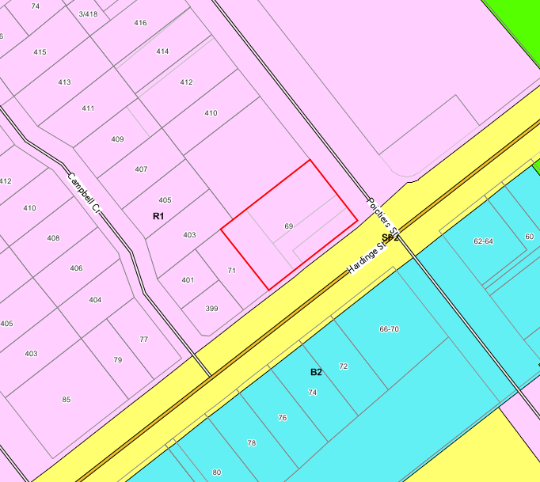

**Figure 1 – 69 Hardinge Street**

The second part of the planning proposal is to rezone Lot 12 DP1105250 Decimus Street from RE1 Public Recreation to R1 General Residential. The location of the land is shown in Figure 2. The subject site has an area of approximately 884m2 and is in private ownership. The subject site is located between two parcels of land. The land to the south west is zoned RE1 Public Recreation and is a Crown Reserve for public recreation under the care and management of Council. The adjoining lot to the north east being Lot 26 DP845007 Decimus Street is zoned R1 General Residential. It is considered that the zoning of lot 12 as RE1 Public Recreation is a zoning anomaly as it is in private ownership and Council has not identified this land for acquisition. The owner of lots 12 and 26 recently lodged a development application for a 7 lot subdivision with part of the road accessing the subdivision to be located on lot 12. Whilst roads are permissible in the RE1 Public Recreation zone, it would be ‘neater’ if lot 12 was zoned R1 General Residential to reflect the adjoining lot. It appears that with the changeover from LEP 1997 to LEP 2013 the zoning of this land was not changed.

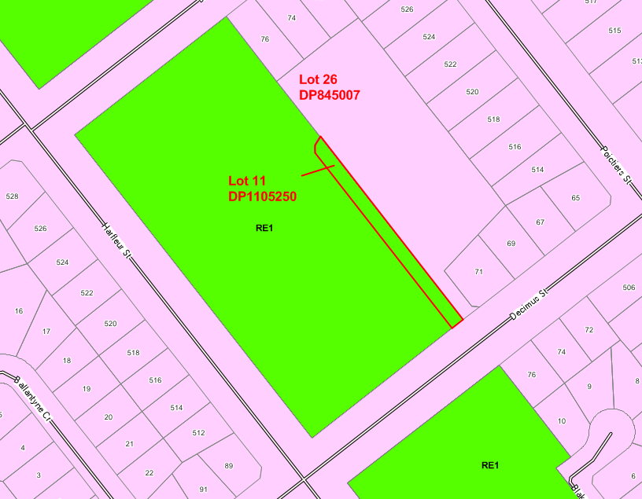

**Figure 3 – Lot 12 DP1105250**

**Planning Proposal**

The planning proposal has been prepared in accordance with ‘*A Guide to Preparing Planning Proposal*’ (NSW Planning Infrastructure, 2012) and is attached.

The following amendments are proposed to LEP 2013:

* **69 Hardinge Street** – amending Land Zoning Map Sheet 5 of the Deniliquin Local Environmental Plan 2013 by changing the zone from R1 General Residential to B2 Local Centre.
* **Decimus Street** – amending Land Zoning Map Sheet 5 of the Deniliquin Local Environmental Plan 2013 by changing the zone from RE1 Public Recreation to R1 General Residential.

**Public Participation and Government Agency Consultation**

It is proposed to exhibit the planning proposal for 14 days and Council will consult with the Roads and Maritime Services in relation to 69 Hardinge Street.

**Strategic Implications:**

An amendment to LEP 2013 is required to achieve the objectives of the planning proposal.

**Budgetary Implications:**

Council’s Fees and Charges 2014/15 requires a fee of $1090 to be paid to initiate a rezoning and then all costs for the rezoning are to be paid by the proponent once the $1090 has been expended. The proponent (owner of 69 Hardinge Street) has paid the fee and has had discussions with the General Manager about paying the costs of the work once the $1090 has been expended.

The owner of the Decimus Street land is not required to pay the cost of the rezoning. This rezoning is to correct an anomaly in the LEP 2013 and is considered to be a routine matter.

**Policy Implications:**

Nil.

**Legislative Implications:**

To amend the LEP 2013 a planning proposal must be prepared in accordance with section 55 of the Environmental Planning and Assessment Act (the Act). This planning proposal is then forwarded to the Department of Planning in accordance with section 56(1) of the Act and a gateway determination is then issued in accordance with section 56(2).

Council will request that the plan making delegations functions be delegated to Council due to the minor nature of the planning proposal. A copy of the request for the delegation of plan making functions to Council is attached.

**Risk Assessment:**

***What can happen?***

Land could be rezoned.

***How can it happen?***

By preparing a planning proposal.

***What are the consequences of the event happening?***

Land is rezoned.

***What is the likelihood of the event happening?***

Unknown. A gateway determination (to determine if the planning proposal should proceed or not) is required from the Department of Planning.

***Adequacy of existing controls?***

Amendments to LEP 2013 have been requested by the owner for one site and have been instigated by Council to correct an anomaly for another site.

***Treatment options to mitigate the risk?***

Prepare a planning proposal.

**Conclusion:**

Council should submit the planning proposal to the Department for a gateway determination.

**Attachments:**

1. Planning Proposal – 22 pages
2. Evaluation Criteria for the Delegation of Plan Making Functions – 4 pages